

**SOFTWARE REQUIREMENT SPECIFICATION (SRS)**

**for**

**mE-ngadu**

**Version 1.0**

**Prepared by:**

NORAEIN BINTI SABTU

MUHAMMAD AKMAL BIN MAHATHIR

MUHAMMAD ZULFADHLI BIN ABDUL RAHMAN

NURHAFIZAH BINTI HASAN

**Supervised by:**

DR. NOVIA

**Revision History**

|  |  |  |  |
| --- | --- | --- | --- |
| **Date** | **Version** | **Description** | **Author** |
| <08/03/2020> | <1.0> | SRS 1.0 | Noraein binti Sabtu  Muhamad Akmal bin Mahathir  Muhammad Zulfadhli bin Abdul Rahman  Nurhafizah binti Hasan |
| <18/05/2020> | <2.0> | SRS 2.0 | Nurhafizah binti Hasan  Noraein binti Sabtu  Muhamad Akmal bin Mahathir  Muhammad Zulfadhli bin Abdul Rahman |

# 

# 

**SECTION 1:INTRODUCTION** **3**

1.1 PURPOSE 3

1.2 SCOPE 4

1.3 DEFINITION, ACRONYMS AND ABBREVIATION 5

1.4 REFERENCES 5

1.5 OVERVIEW 5

**SECTION 2: OVERALL DESCRIPTION** **6**

2.1 PRODUCT PERSPECTIVE 6

2.2 PRODUCT FUNCTIONS 6

2.3 USER CHARACTERISTICS 6

2.4 CONSTRAINTS 7

2.5 ASSUMPTIONS AND DEPENDENCIES 7

**SECTION 3: SYSTEM FEATURES** **8**

3.1 WEBSITE 8

3.1.1 Features Overview Table 8

3.1.2 Use Case Diagram 9

3.1.3 Use Case Description 10

**SECTION 4: FUNCTIONAL REQUIREMENT (FR)** **14**

**SECTION 5: NONFUNCTIONAL REQUIREMENT (NFR)** **15**

5.1 Performance Requirements 15

5.2 Safety Requirements 15

5.3 Security Requirements 15

5.3.1 Identification Requirements 15

5.3.2 Authentication Requirements 15

5.3.3 Integrity Requirements 15

5.4 Software Quality Attributes 16

5.4.1 Accessibility Requirements 16

5.4.2 Usability Requirements 16

**SECTION 6: USER INTERFACE DESIGN** **17**

# 

# **SECTION 1:INTRODUCTION**

## **1.1 PURPOSE**

mE-ngadu is a web-based application system that is developed to ease the complaint procedure in the Computer Science and Information Technology (CSIT) faculty. The purpose of mE-ngadu is to ensure that the students and employees at CSIT faculty have an appropriate platform to make complaints regarding any issues that have been happening in the faculty. The flow of the current complaint management system in the CSIT faculty is not clear and the students and employees are always confused on who to deal with or where they should lodge their complaint as the current way to lodge a complaint at the faculty is very inconvenient. The complaint made is not properly documented which can be a problem towards both the management and the one who complains because the complaint may not be conducted at all because we do not know about the progress of the complaint. It is also hard to track the progress of the complaint because the current complaint system does not support a real-time update about the complaint that has been made which makes it difficult for the one who complains to see the progress on the complaint made. Therefore, mE-ngadu helps to overcome the limitations that the current complaint system that the faculty is using in order to ensure that the weaknesses and limitation mentioned above can be handled.

## **1.2 SCOPE**

The scope for mE-ngadu is only evolving around the community at the CSIT faculty which includes the students and employees. mE-ngadu is a web-based application system that will allow the users to lodge complaints easily without having to meet or hand in any paper based document to the person in-charge . The proposed web-based system enables users to track the real-time status of the complaint that has been made therefore it would be easier for them to keep track of their complaint status. me-Ngadu ensures that there are no complaints left behind as all the complaints made are stored in the database that will ensure that no complaints are overlooked.

## **1.3 DEFINITION, ACRONYMS AND ABBREVIATION**

|  |  |
| --- | --- |
| SRS | Software Requirement Specification |
| PMP | Project Management Plan |
| SDD | Software Design Document |
| IEEE | Institute of Electrical and Electronics Engineers |
| V&V | Verification and Validation |
| SDLC | Software Development Life Cycle |
| FR | Functional Requirement |
| NFR | Non-Functional Requirement |
| JSF | Java Servlet Page |

## **1.4 REFERENCES**

[1] IEEE Software Engineering Standards Committee, “IEEE Std 830-1998, IEEE Recommended Practice for Software Requirements Specifications”, October 20, 1998

## **1.5 OVERVIEW**

The upcoming sections of the document will explain the characteristics and general description of mE-ngadu which includes the stakeholders of the system itself. It will also explain about the software that will be used while developing this web-based application system. The general description of mE-ngadu will be discussed in section 2 which will explain in detail about the functions, characteristics, constraints and also the assumption and dependencies in this project. Section 3 will focus on the features of the proposed system that will include the use case diagram and the use case description of mE-ngadu. Section 4 and 5 will highlight the functional and nonfunctional requirements that will be implemented in the system that we are developing.

# **SECTION 2: OVERALL DESCRIPTION**

## **2.1 PRODUCT PERSPECTIVE**

**mE-ngadu** is a progressive web application system. It will be accessible through two (2) mediums which are smartphone and PC. The web will be built as a platform that will allow CSIT students to send their complaints. This system will be able to send a notification when a complaint is already sent to the higher ups. It also includes the real-time status about the complaint status whether the status has already been read by the higher ups or already taken action on the complaint.

Since this system will store all the complaints, it will require a database to store the complaints. Therefore a database will be used in this project.

## **2.2 PRODUCT FUNCTIONS**

**mE-ngadu** is a platform that will allow the users to login as a student or a staff member. This system will allow the user to access the website to write a complaint about the faculty. It will also allow the user to track the complaint whether the complaint is already read or already take an action on it.

## **2.3 USER CHARACTERISTICS**

Our users will be the students or staff that use the **mE-ngadu** to complain about the faculty. The users will be able to write a complaint, send the complaint and track the status of the complaint.

## **2.4 CONSTRAINTS**

1. The constraints that may be faced is internet connection availability. Since this device relies highly on the internet connection to upload the data to the database, so a continuous internet connection to ensure miss loss of data during a reading.
2. Too many users at one time using the system, the server for the system will be down because too many users try to login into the system

**2.5 ASSUMPTIONS AND DEPENDENCIES**

The identified assumptions and dependencies for this system are as follow:

1. **mE-ngadu** will be available in any operating system such as macOS, WindowOS and LinuxOS. If the operating system is not available, the SRS needs to be changed.
2. Users need to have internet connection to or internet access to login into the website.
3. The system will be available to the user for 24 hours.
4. **mE-ngadu** will be using UPM email to login or sign up to the website. Non-UPM students cannot login into the system.
5. MVC framework will be used to develop the website.
6. Google Maps will be used as the third party services. Google Maps will help in directing the user to see the person in charge in the faculty.
7. The system require database server to store the complaint in the system

# 

# **SECTION 3: SYSTEM FEATURES**

## **3.1 WEBSITE**

### **3.1.1 Features Overview Table**

|  |  |  |
| --- | --- | --- |
| **Feature** | **Description** | **Use Case** |
| 1.0) Sign Up | Enable the user to sign to use the website | 1.1 Sign Up |
| 2.0) Login | The user and admin should be able to login to the system according to their user privilege | 1.2 Login |
| 3.0) Submit Complaint | The user will submit their complaint to the system | 2.1 Submit Complaint |
| 4.0) View Complaint Status | The user and admin will be able to check the submitted complaint status either success or fail | 2.1 Submit Complaint |
| 2.2 View Status |
| 5.0) View Complaint | The admin and user can check the existing complaint list | 3.1 View Complaint |
| 6.0) Manage Complaint | The admin will be able to manage the  submitted complaint by the user.  It includes the delete and update the  complaint status. | 3.1 View Complaint |
| 3.2 Manage Complaint |

### **3.1.2 Use Case Diagram**

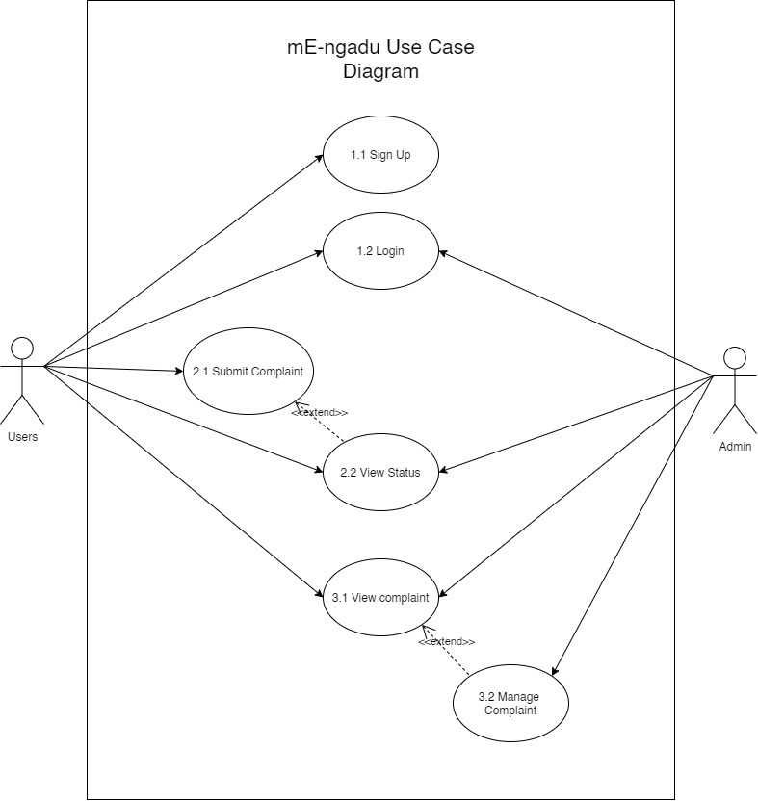

### 

### **3.1.3 Use Case Description**

|  |  |
| --- | --- |
| **Identifier** | **1.1** |
| **Name** | **Sign Up** |
| **Description** | **A button that will redirect the user to the sign up page.** |
| **Actor** | **User** |
| **Flow of Events** | 1. **Users click on the sign up button.** 2. **The web will redirect the users to a new page.** 3. **The user fills in the necessary details.** 4. **The system will check for duplication in email address and matric number.** |
| **Alternative Flow** | **4.1 Duplicated email or matric number found**  **4.1.1 If duplicated email or matric number is found, the system will prompt an error to the user to fix it.** |
| **Pre -Condition** | **N/A** |
| **Post-Condition (s)** | **Users' login details will be written in the database.** |

|  |  |
| --- | --- |
| **Identifier** | **1.2** |
| **Name** | **Login** |
| **Description** | **A button that will redirect the user to the sign up page.** |
| **Actor** | **User** |
| **Flow of Events** | 1. **User will fill in the username and password** 2. **User click login button** 3. **The system will check the details** 4. **User will be redirected to the homepage** |
| **Alternative Flow** | **3.1 If username or password is wrong, the system will prompt the user to reenter the correct one** |
| **Pre -Condition** | **User must have complete the signup** |
| **Post-Condition (s)** | **User’s will be able to use the complaint function.** |

|  |  |
| --- | --- |
| **Identifier** | **2.1** |
| **Name** | **Submit Complaint** |
| **Description** | **A button that allow the user to submit their complaint** |
| **Actor** | **User** |
| **Flow of Events** | 1. **The user click the new complaint button** 2. **The user will be required to fill in the complaint text box.** 3. **The system will check the text box to check if any text has been inputted** 4. **The user click the submit button** |
| **Alternative Flow** | **3.1 The system will prompt the user to fill in the empty text box.** |
| **Pre -Condition** | **User must login to the system** |
| **Post-Condition (s)** | **The complaint will be stored in the database** |

|  |  |
| --- | --- |
| **Identifier** | **2.2** |
| **Name** | **View status** |
| **Description** | **It allow the user and admin to check the current status of the complaint** |
| **Actor** | 1. **User** 2. **Admin** |
| **Flow of Events** | 1. **The user will select the complaint submission** 2. **The system will display the current status of the complaint** |
| **Alternative Flow** | **N/A** |
| **Pre -Condition** | 1. **User must login to their account** 2. **User need to submit their complaint** |
| **Post-Condition (s)** | **N/A** |

|  |  |
| --- | --- |
| **Identifier** | **3.1** |
| **Name** | **View Complaint** |
| **Description** | **The admin and user will be able to view all the submitted complaint** |
| **Actor** | 1. **User** 2. **Admin** |
| **Flow of Events** | 1. **The user will select the view complaint button** 2. **The system will display the list of current submitted complaint** 3. **The user will be able to select the complaint to view the details** |
| **Alternative Flow** | **N/A** |
| **Pre -Condition** | **The user must login to the system** |
| **Post-Condition (s)** | **N/A** |

|  |  |
| --- | --- |
| **Identifier** | **3.2** |
| **Name** | **Manage complaint** |
| **Description** | **The admin will be able to update or delete the complaint** |
| **Actor** | **Admin** |
| **Flow of Events** | 1. **The admin will select the edit button on the complaint list** 2. **The system will prompt the delete or update button** 3. **The admin choose the button** |
| **Alternative Flow** | **3.1. The admin select the delete button**  **3.1.1 The system will prompt the confirmation button**  **3.1.2 The admin will select confirm button**  **3.1.3 The system will remove the complaint from the database**  **3.2. The admin select the update button**  **3.2.1 The system will redirect the admin to the update page**  **3.2.2 The admin will update the complaint status and save the change** |
| **Pre -Condition** | 1. **The admin need to login from the admin account** |
| **Post-Condition (s)** | **The system will update the updated complaint or remove the deleted complaint from the database** |

# 

# **SECTION 4: FUNCTIONAL REQUIREMENT (FR)**

This section describes the Functional Requirement of Me-Ngadu.

|  |  |  |
| --- | --- | --- |
| ID | Description | Use Case ID |
| 1 | This FR enables a person to register themselves into the Me-ngadu System as a normal user. | UC1.1 |
| 2 | This FR is for a registered user or admin to log on into the system and access further features provided by the system. | UC1.2 |
| 3 | This FR is for a registered user to submit any complaint to the system. | UC2.1 |
| 4 | This FR is for a registered user and admin to check or view the current status of a submitted complaint by a registered user. | UC2.2 |
| 5 | This FR is for a registered user and admin to check or view any submitted complaint by a registered user in a list form.. | UC3.1 |
| 6 | This FR is for the admin to handle or manage all submitted complaints by a registered user. This includes the function to delete any complaint or update complaint status. | UC3.2 |

# 

# **SECTION 5: NONFUNCTIONAL REQUIREMENT (NFR)**

## 5.1 Performance Requirements

The system shall be able to respond to any operation within 3-5 seconds of user input. In a normal condition, the system shall be able to cope with 100 user requests per second. The failure rate of the system shall not exceed 1 failure for every 1000 operations by the users. A 99% of uptime shall be implemented to the system.

## 5.2 Safety Requirements

Any breached happens to the system shall be stop by not permitting further operation in the system unless there is any operator guard at the scene. Users' accounts may be suspended if any security breaches are found.

## 5.3 Security Requirements

### 5.3.1 Identification Requirements

New user needs to be registered first before any further operation to the system can be done. This is to make sure only identified users are able to have access to the system.

### 5.3.2 Authentication Requirements

The system must be able to verify and identify the client before giving any permission or authorization to the system. Users are required to log in first everytime they want to have access to the system.

### 5.3.3 Integrity Requirements

The system shall not permit any unauthorized manipulation off any communications passing through the networks which are external to any protected data. The system also shall not permit any unauthorized manipulation tot the system database and users data.

5.4 Software Quality Attributes

### 5.4.1 Accessibility Requirements

The extent of which the system can be used by people with a wide variety of skills to reap a targeted aim in a specified context of use is the accessibility requirements. Our system shall cater to the humans who are color blind with the usage of color of text and background that can be perceived by them.

### 5.4.2 Usability Requirements

The system shall be user friendly and implement a minimalistic concept to provide an easy to use operations for the user. Users would not need to receive any training to use the system as most of the functions are visible and easy to understand. A set of usability testing will be done to ensure the usability of the system.

# 

# **SECTION 6: USER INTERFACE DESIGN**

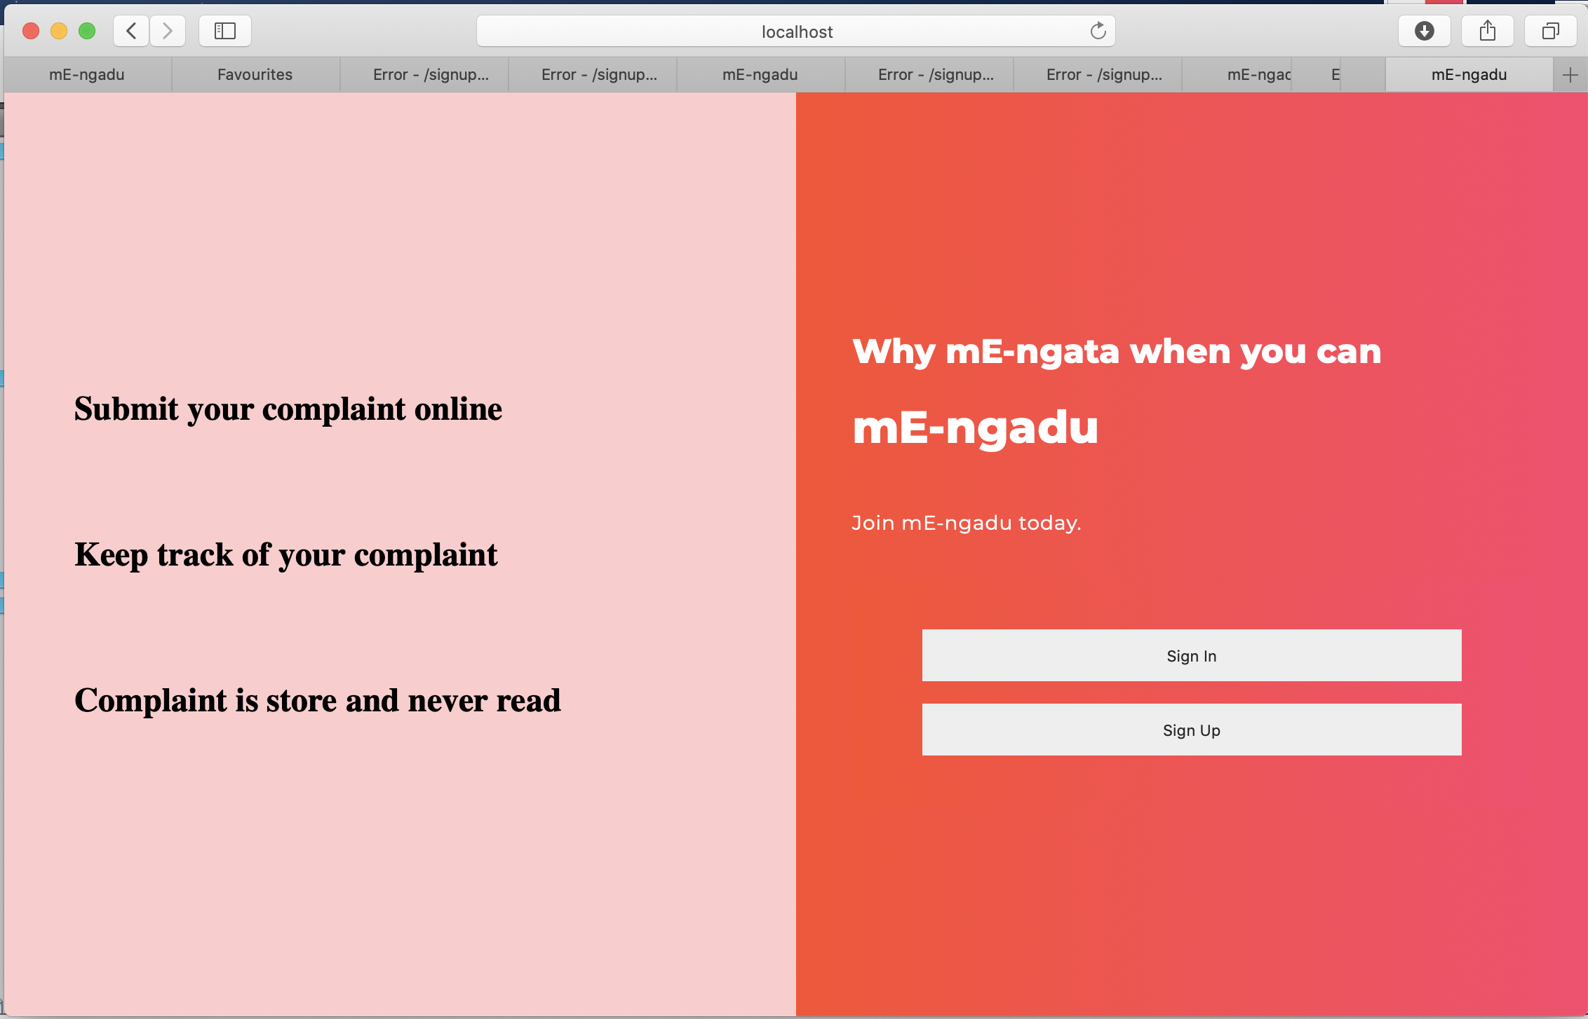

Figure 6.1 mE-ngadu main windows

The mE-ngadu main window is the first interface that the user will see once they open the system. This user interface allows the user to either Sign in or Sign Up.

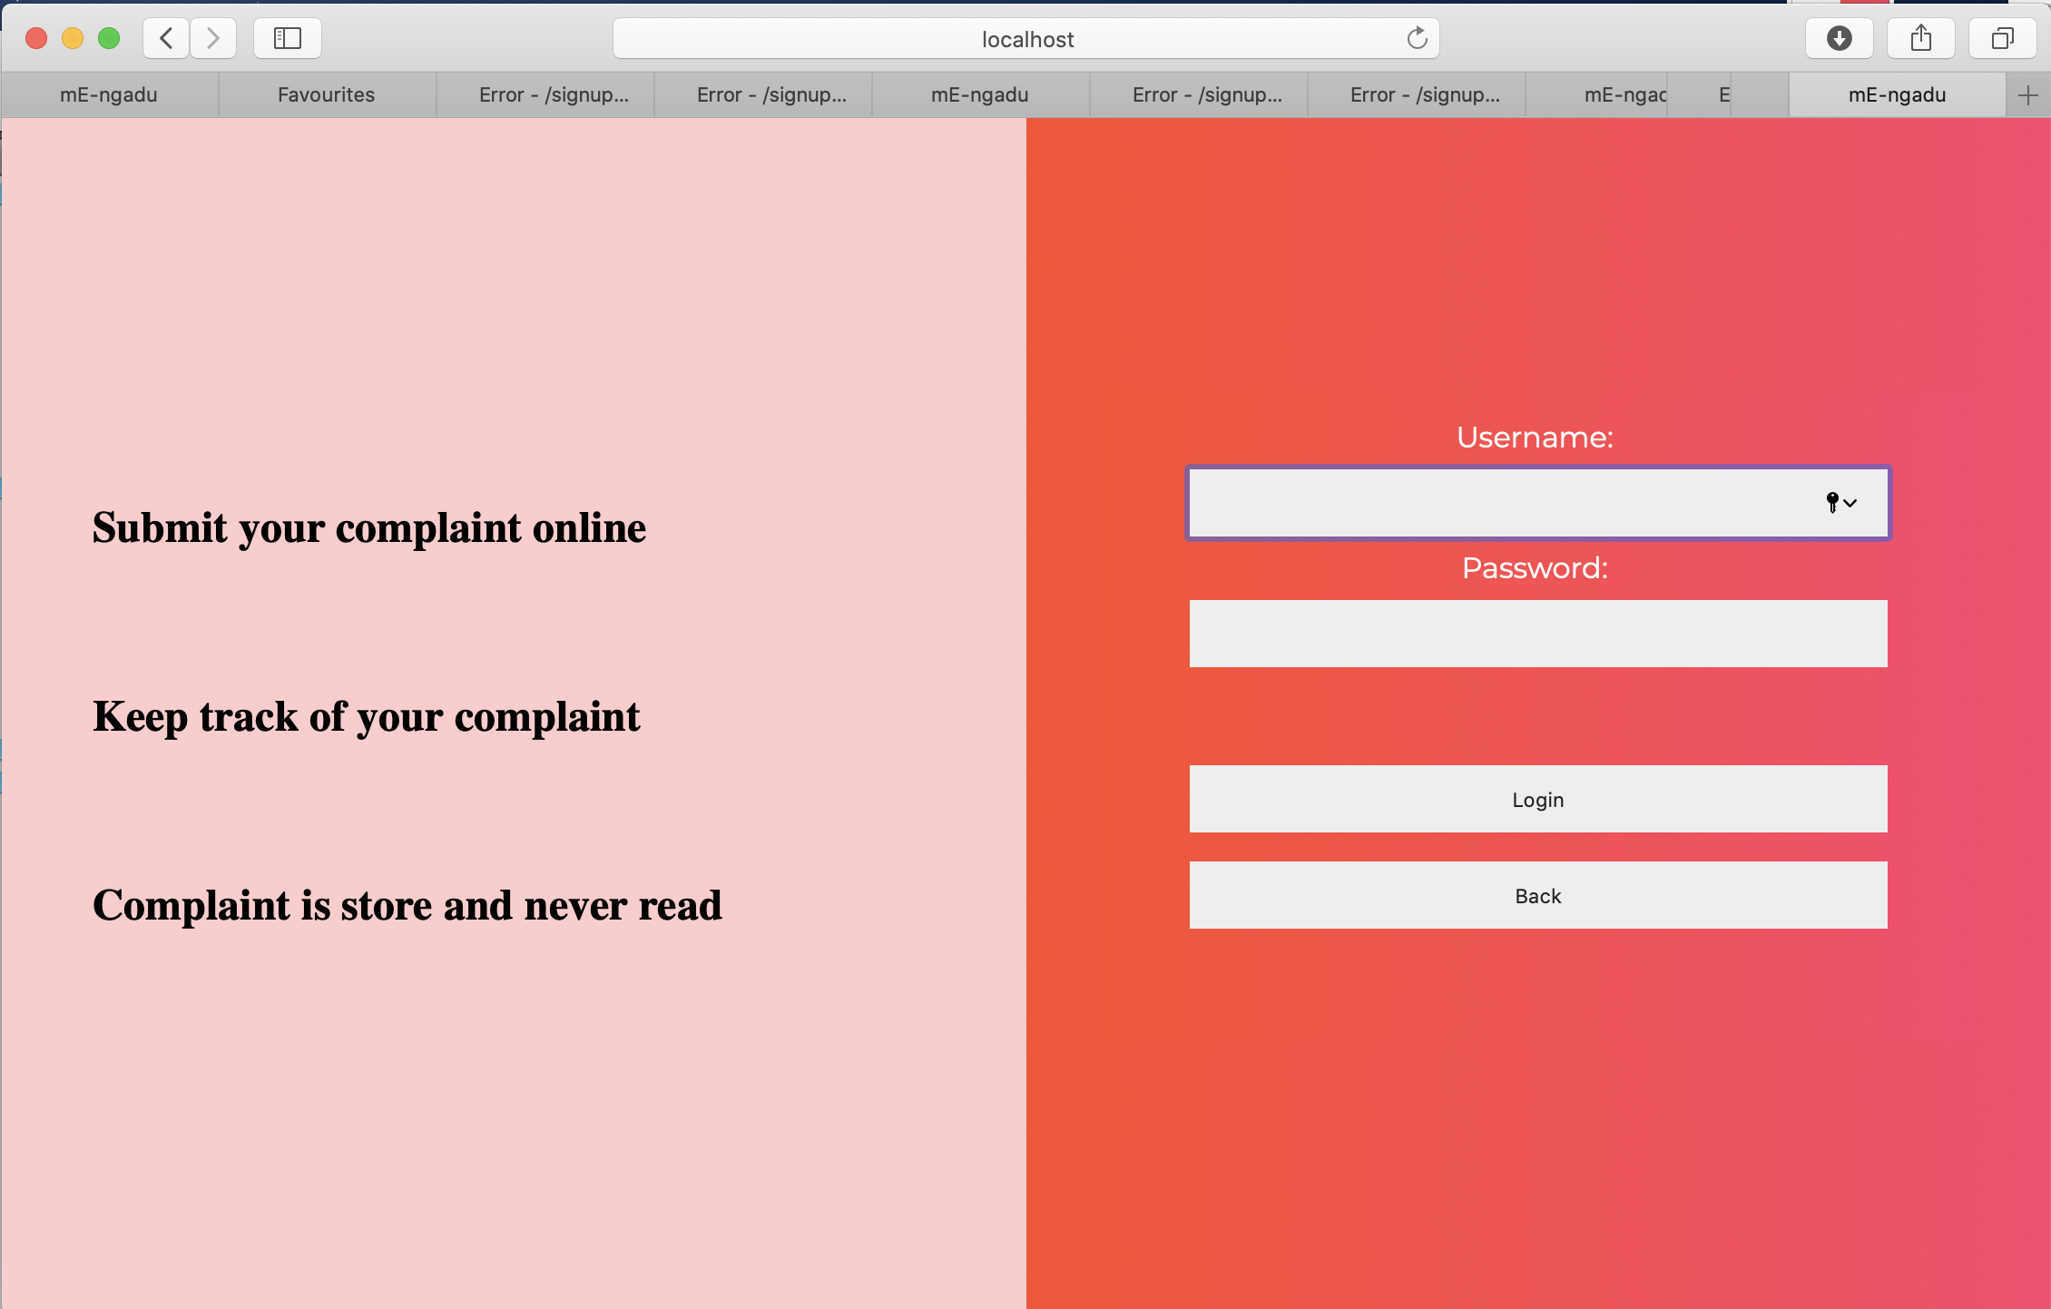

Figure 6.2 Sign in User Interface

When the user clicks the Sign in button on the main window, they will be redirected to the Sign in user interface. Users are required to fill in their username and password at the textfield provided in order for them to login.

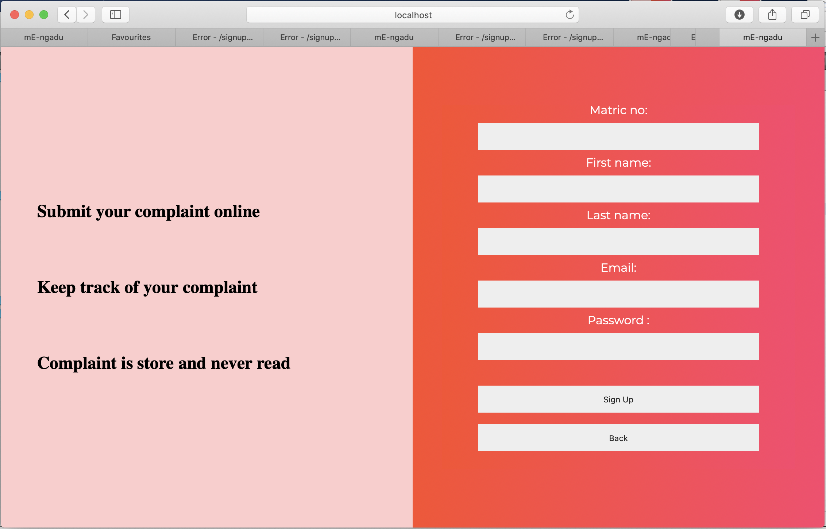

Figure 6.3 Sign up User Interface

If the user does not have an account, he or she can click the Sign Up button at the main window so that they will be redirected to the Sign Up user interface. On this interface, users should fill in their basic information such as matric no, first name, last name, email and password in order to create an account. Once the user has created an account, they can Sign in as usual.

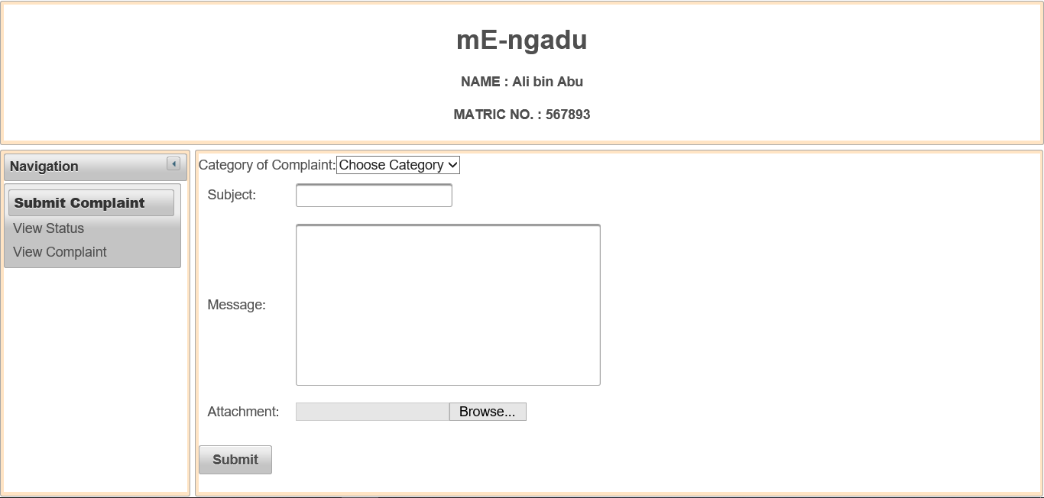

Figure 6.4 Submit Complaint User Interface

This interface is for submitting complaints. Users can click at the “Submit Complaint” button and there are a few details users need to fill the “Category of Complaint'', “Subject”, “Message” and “Attachment” in order to submit the complaint. The attachment is optional for the user whether user want to upload something or not.

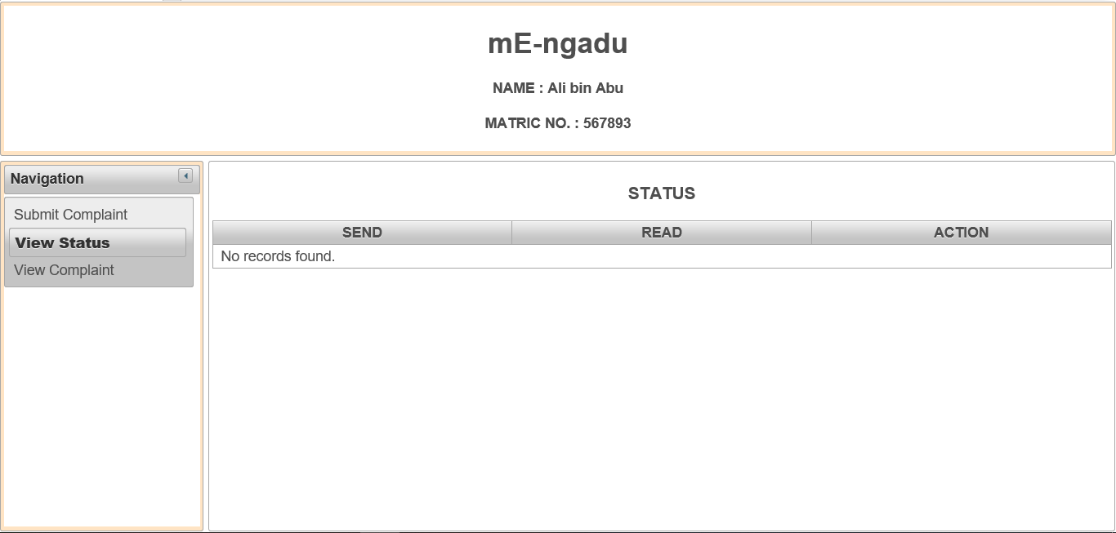

Figure 6.5 View Status User Interface

This user interface is View Status. View status helps users to track their complaint whether the complaint is “Send”, “Read” or “Action”. “Action” is the action taken to the complaint. Users can know the status of their complaint.

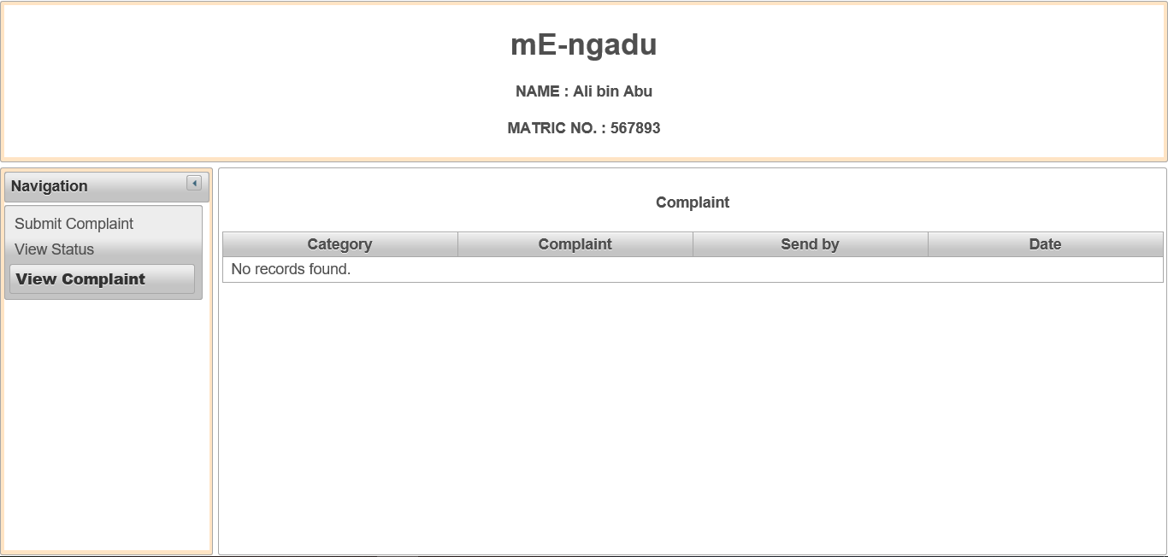

Figure 6.4 View Complaint User Interface

This interface shows the View Complaint. In this interface, a user can view other complaints made by the other user. They can check other people's complaints.